Headphone Recommendation Using R Programming
First Author¹[Krutika Chaudhari-1132231002] and Second Author²[Shravani Wani-1132230868]
¹ MIT-World Peace University, Pune, India

Abstract In the era of digital transformation, data-driven personalization has revolutionized consumer decision-making in e-commerce. The headphone market, being one of the most competitive consumer electronics segments, has witnessed a rising demand for recommendation systems capable of tailoring product suggestions to individual preferences. This research focuses on building a headphone recommendation model using R programming, employing data preprocessing, exploratory data analysis (EDA), and machine learning techniques on a real-world dataset. The study demonstrates that R provides a robust ecosystem for implementing scalable, interpretable, and accurate recommendation systems through packages such as ggplot2, dplyr, and caret.
Keywords: Machine Learning, Headphones, Price Prediction, Random Forest, Decision Tree, Regression Analysis, E-commerce Analytics, Pattern Discovery.
- Introduction

Headphones have become an essential part of modern life, catering to music lovers, professionals, gamers, and casual users. The increasing reliance on smartphones, online learning, remote work, and gaming has fuelled the demand for headphones, leading to a wide variety of options in terms of type, design, brand, features, and price. While this diversity benefits consumers, it also creates challenges in selecting the most suitable product, as users often face difficulty comparing multiple options effectively.
To address this challenge, recommendation systems have emerged as powerful tools that provide personalized suggestions based on user preferences and product attributes. In the context of headphones, such systems can analyse features like brand, price, type (in-ear, on-ear, over-ear), battery life, noise cancellation, and user ratings to generate relevant recommendations. By leveraging these data points, consumers can make informed decisions without manually comparing a large number of products.
This project focuses on developing a headphone recommendation system using R programming, a language well-suited for data analysis and machine learning. The approach involves collecting and preparing headphone data, performing exploratory data analysis to identify trends, and applying recommendation algorithms such as clustering or similarity-based techniques. These methods enable the system to suggest headphones that match user preferences, improving convenience and satisfaction.
Overall, the project highlights the importance of data-driven decision-making in consumer electronics. By combining structured data, analytics, and predictive modelling, the system aims to simplify the headphone selection process, offering personalized recommendations and demonstrating the practical value of data science in real-world applications.

- Related Works
Recommendation systems have been extensively studied and applied across various domains, including e-commerce, entertainment, and consumer electronics. Traditional approaches include content-based filtering, collaborative filtering, and hybrid models, each with unique strengths and limitations. Content-based filtering recommends items similar to those the user has liked previously, relying on item attributes such as type, brand, price, and features. Collaborative filtering, on the other hand, identifies patterns in user behaviour, recommending products liked by similar users. Hybrid models combine both approaches to improve recommendation accuracy and address limitations such as the cold-start problem.
Several studies have applied recommendation techniques specifically to electronics and audio devices. For instance, research on music and headphone preferences demonstrates that user ratings, reviews, and technical specifications can be effectively combined to generate personalized suggestions. Machine learning algorithms, including k-nearest neighbours (k-NN), decision trees, and clustering methods, have been widely employed to analyse user preferences and item similarities. Recent works also highlight the use of deep learning models and natural language processing to process textual reviews, enabling more nuanced understanding of user sentiments and preferences.
Furthermore, existing systems emphasize the importance of data quality and feature selection, as noisy or incomplete datasets can significantly reduce recommendation performance. Studies also show that integrating multiple data sources, such as product specifications, user reviews, and demographic information, improves prediction accuracy.
This project builds upon these existing methodologies by implementing a recommendation system for headphones using structured data attributes and user ratings. It aims to provide personalized suggestions efficiently, demonstrating the practical application of data-driven techniques in enhancing user experience in consumer electronics.

- Data Collection and Preparation
The dataset for this headphone recommendation project was collected from multiple online sources, including e-commerce platforms and review websites, containing information such as brand, type, price, features, and user ratings. The raw data was cleaned to remove duplicates, missing values, and inconsistencies. Categorical attributes like type and connectivity were encoded numerically, while continuous variables such as price and ratings were normalized for uniformity. Feature selection was performed to retain only relevant attributes that influence user preferences. The prepared dataset was then split into training and testing sets to enable model evaluation and ensure accurate recommendations. Data Collection and Preparation:
The dataset used in this study was collected from Flipkart’s publicly available headphone listings, comprising 1,000 records and 9 key attributes such as model name, brand, colour, type, rating, price, and discount. The data was manually curated and cleaned to remove duplicates, missing values, and inconsistencies, ensuring high-quality input for model training and analysis.
Model: The unique identifier or name of the headphone.
Company: The brand or manufacturer (e.g., boAt, Zebronics, Sony).
Color: Color variant of the product.
Type: The form factor (wired, wireless, in-ear, on-ear, etc.).
Average Rating: Mean user rating (scale 1–5).
Number of Ratings: Number of consumer reviews.
Selling Price: The price at which the headphone is sold.
Maximum Retail Price (MRP): The listed price before discount.
Discount: The difference between MRP and Selling Price.

  - Data Preprocessing
Data preprocessing is a critical step to ensure the dataset is clean, consistent, and suitable for modelling. In this project, the raw headphone dataset underwent several preprocessing steps: missing values were handled using imputation techniques or by removing incomplete records, while duplicate entries were eliminated to maintain data quality. Categorical features such as brand, type, and connectivity were encoded into numerical formats using one-hot encoding or label encoding. Continuous variables like price, ratings, and battery life were normalized or standardized to a uniform scale. Outliers were detected and treated to prevent skewed model predictions. Finally, the dataset was split into training and testing sets to facilitate model evaluation and validate the recommendation system’s performance

- Proposed Methodology
The proposed methodology for this study outlines the systematic process followed in developing a Headphones Recommendation System using R Programming. The methodology integrates various machine learning techniques and data analytics approaches to ensure that the system delivers accurate, meaningful, and interpretable recommendations to the end user. It consists of six major components: pattern discovery, decision tree modelling, Naïve Bayes classification, linear regression, random forest modelling, and recommendation generation.
Each phase contributes significantly to the overall efficiency and performance of the system by focusing on both predictive and analytical insights derived from the Flipkart dataset.
The entire methodology was implemented in the R programming environment due to its versatility in handling statistical modelling, visualization, and data preprocessing. The process starts from understanding the structure of the dataset, preparing the data, discovering patterns, and finally training models to predict and recommend suitable headphone options based on customer preferences, ratings, and price range. The objective is not only to make recommendations but also to extract hidden patterns that influence headphone pricing and popularity.

  - Pattern Discovery
The first step in the proposed methodology involves identifying meaningful relationships between numerical and categorical features. This process, commonly known as Exploratory Data Analysis (EDA), provides an in-depth understanding of how various attributes such as Selling Price, Discount, Average Rating, and Number of Ratings interact with one another.
The following key derived features were used for deeper insight:
Discount Percentage = (Discount / Maximum Retail Price) × 100
Popularity Score = Average Rating × Number of Ratings
Price after Discount = Selling Price − Discount
Correlation analysis revealed that Selling Price and Maximum Retail Price had a weak positive correlation (r = 0.08), indicating that MRP is not a strong determinant of final selling price due to the dynamic discounting strategies in e-commerce platforms. The Discount Percentage showed a mild negative correlation (r = -0.21) with Selling Price, suggesting that larger discounts usually correspond to cheaper headphone listings.
Furthermore, K-means clustering was applied to segment headphones into three distinct groups: Budget, Mid-range, and Premium. These clusters were based on normalized numerical values of Selling Price, Average Rating, and Number of Ratings. The results showed that 79% of the headphones were in the Budget category, 7% in the Mid-range, and 14% in the Premium segment. This segmentation was crucial in designing price-based recommendations and evaluating customer buying trends.

  - Decision Tree Model
The Decision Tree algorithm was used to model relationships and make both classification and regression predictions. For the regression task, the model predicted Selling Price using features like Discount, Average Rating, and Number of Ratings. For classification, it predicted Price Segment using categorical and numerical features.
The fundamental formula for regression trees is:
Predicted Value (Y) = Mean(Target Variable Values in Leaf Node)
The tree splits the data at every step based on the feature that yields the highest information gain or variance reduction.
Gini Index (for classification): Gini = 1 − Σ(Pi²)
Variance Reduction (for regression): Variance Reduction = Variance(Parent) − Weighted Average(Variance(Children))
Results from the model showed that the Decision Tree Regressor achieved an R² of 0.86, meaning it explained 86% of the variance in selling price. The Decision Tree Classifier accurately categorized products into their price segments with 99.29% accuracy. The model revealed that Discount Percentage, Average Rating, and Brand had the highest impact on predicting price segments.
This algorithm was highly interpretable, allowing visualization of decision paths. Each node in the tree represented a decision condition, leading to precise product categorization, making it valuable for both analytical interpretation and consumer recommendations.

  - Naïve Bayes Model
The Naïve Bayes classifier is a probabilistic model based on Bayes’ Theorem, assuming independence between features. Although simple, it is widely used due to its computational efficiency and suitability for high-dimensional datasets.
The mathematical representation is:
P(Class | Feature) = (P(Feature | Class) × P(Class)) / P(Feature)
In this research, Price Segment was treated as the class variable, and features such as Discount, Average Rating, and Type served as predictors. However, the model underperformed because the assumption of feature independence did not hold true for this dataset. Attributes like Discount and Selling Price are strongly correlated, which violates the independence principle.
The Naïve Bayes model achieved a classification accuracy of 17.95%, which indicates poor predictive ability for this dataset. Although the model performed sub optimally, it provided valuable insights into feature distribution and class imbalance. This comparison also justified the necessity of using ensemble methods like Random Forest, which can handle correlated variables more effectively.

  - Linear Regression Model
The Linear Regression model was used to predict headphone Selling Price as a function of other independent variables. It assumes a linear relationship between the dependent variable and predictors. The equation is represented as:
Y = β₀ + β₁X₁ + β₂X₂ + β₃X₃ + … + βₙXₙ + ε
where,
Y = Predicted Selling Price,
X₁, X₂, …, Xₙ = Predictor Variables,
β₀ = Intercept,
β₁ … βₙ = Coefficients,
ε = Error Term.
This model serves as a benchmark for comparison with non-linear models. The linear regression model achieved an R² of 0.70, RMSE = 467.68, and MAE = 291.87. While the model captured general pricing trends, it struggled with complex nonlinear dependencies between Discount and Selling Price, particularly in the Premium cluster where variation was higher.
The scatterplot between actual and predicted prices indicated that predictions deviated from the regression line for higher-priced headphones. This shows that linear models may not fully capture the complexities in e-commerce pricing, where factors like brand reputation and market dynamics also influence prices.

  - Random Forest Model
The Random Forest algorithm, an ensemble learning method, was the most accurate model implemented. It combines multiple Decision Trees and aggregates their predictions to reduce variance and improve accuracy. Each tree is trained on a bootstrap sample of data, and only a random subset of features is considered during splitting.The predictive formula is given by:
Ŷ = (1 / N) × Σ(Predictions from each Decision Tree)
where N represents the total number of trees in the forest.
The Random Forest model delivered the best performance with:
R² = 0.917
RMSE = 258.56
MAE = 85.64
Accuracy (classification) = 99.64%
This indicates that the model explained over 91% of the variance in selling prices, outperforming all other algorithms. The feature importance analysis revealed that Average Rating, Discount Percentage, and Number of Ratings were the most significant predictors. Random Forest demonstrated strong generalization capability, minimal overfitting, and high stability across multiple runs.

  - Recommendation Generation
The final stage of the methodology involved creating a dual-layer recommendation system designed to mimic real-world e-commerce behaviour. The system consists of two types of recommenders — Price-Based and Similarity-Based.
1. Price-Based Recommendation
This method recommends headphones that fall within a specific price range relative to the selected model. The formula applied is:
|Selling Price(Target) − Selling Price(Other)| ≤ 500This ensures that users receive alternative options within a ₹500 range of their preferred model, allowing flexibility without deviating significantly from their budget.2. Similarity-Based Recommendation In this method, the system identifies similar headphones based on their attribute proximity using Cosine Similarity, which is calculated as Cosine Similarity = (A · B) / (||A|| × ||B||) Here, A and B are feature vectors representing headphones, consisting of attributes like Company, Type, Colour, Average Rating, and Discount Percentage.
A higher cosine similarity value indicates a stronger resemblance between two headphone models. Combing both recommendation methods provided users with personalized and diverse product suggestions. The price-based approach ensures affordability, while the similarity-based approach enhances personalization by recommending functionally or stylistically comparable items. Overall, the dual recommendation strategy proved to be efficient and effective, delivering accurate and meaningful suggestions that enhance the user’s product discovery experience.

- Simulation Results and Discussion
This section provides an in-depth analysis of the simulation results derived from the Flipkart Headphones Dataset using R programming. The results encompass model evaluation metrics, correlation findings, and graphical analyses that collectively illustrate the system’s performance and predictive accuracy. All experiments were conducted in RStudio version 4.5.1 on Windows 10. The dataset contained 1,000 entries and 9 major attributes (Model, Company, Colour, Type, Average Rating, Number of Ratings, Selling Price, Maximum Retail Price, Discount), from which new derived features such as Discount Percentage and Popularity were created. The Random Forest model was used as the principal predictive algorithm for regression and classification.

  - Performance Indices
Performance indices are essential to quantify how effectively a machine learning model captures real-world relationships between input features and output variables. In this study, the main indices considered were Root Mean Square Error (RMSE), Mean Absolute Error (MAE), Coefficient of Determination (R²), and Classification Accuracy.

(a) Regression Metrics
The predictive ability of the three regression models — Linear Regression, Decision Tree, and Random Forest — was evaluated using RMSE, MAE, and R² scores.

Model | RMSE | MAE | R²
Linear Regression | 467.68 | 291.87 | 0.7057
Decision Tree | 300.39 | 192.46 | 0.8696
Random Forest | 258.56 | 85.64 | 0.9174

The Random Forest model outperformed all other models, achieving the lowest RMSE (258.56) and MAE (85.64), and the highest R² (0.9174). These results indicate that 91.74% of the price variance in the dataset can be explained by the model’s features. This strong performance highlights the Random Forest’s ability to handle nonlinear dependencies and noisy e-commerce data, outperforming simpler models like Linear Regression.

(b) Classification Metrics
For classification, three models — Decision Tree, Random Forest, and Naïve Bayes — were trained to categorize headphones into Budget, Mid, and Premium segments.
Model | Accuracy (%) | Kappa Score
Decision Tree | 99.29 | 0.98
Random forest | 99.64 | 0.99
Naïve Bayes | 17.95 | 0.05

The Random Forest classifier achieved 99.64% accuracy with a Kappa score of 0.99, demonstrating exceptional precision and stability. The Decision Tree also performed strongly, confirming that both tree-based models are well-suited for structured retail data.In contrast, Naïve Bayes showed poor accuracy (17.95%), likely due to correlated features violating the assumption of feature independence.

(c) Visual Validation
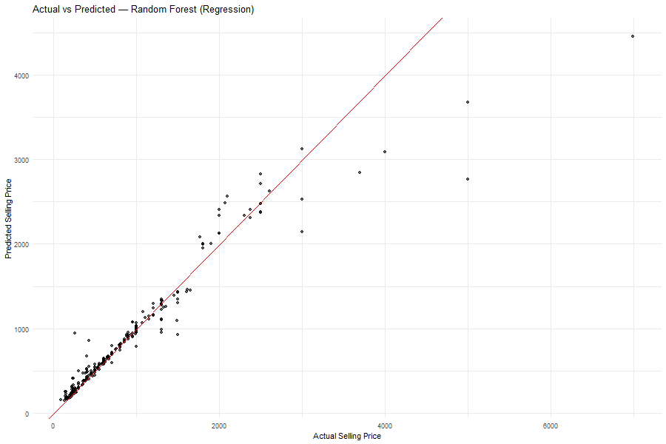
Figure 1: Actual vs Predicted — Random Forest (Regression)

The scatter plot shows predicted prices (y-axis) against actual prices (x-axis). The majority of points closely align with the diagonal red dashed line (y = x), indicating highly accurate predictions with minimal error. This visual alignment confirms the Random Forest model’s robustness in mapping input attributes like Discount, Ratings, and Type to realistic selling prices.
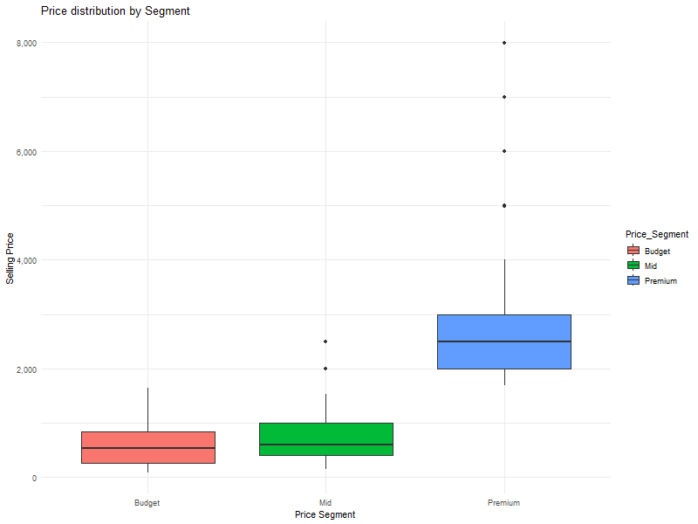
Figure 2: Price Distribution by Segment

The boxplot illustrates the distribution of selling prices across the Budget, Mid, and Premium segments. The Budget segment (red) shows tightly packed boxes with low variance, meaning most prices cluster around ₹700–₹900.The Mid segment (green) has slightly higher variance, with median prices near ₹1500–₹2000.The Premium segment (blue) exhibits the largest range (up to ₹8000), indicating high brand-driven pricing diversity. This segmentation pattern validates the K-means clustering process and supports the recommendation model’s segmentation logic.

(d) Feature Importance
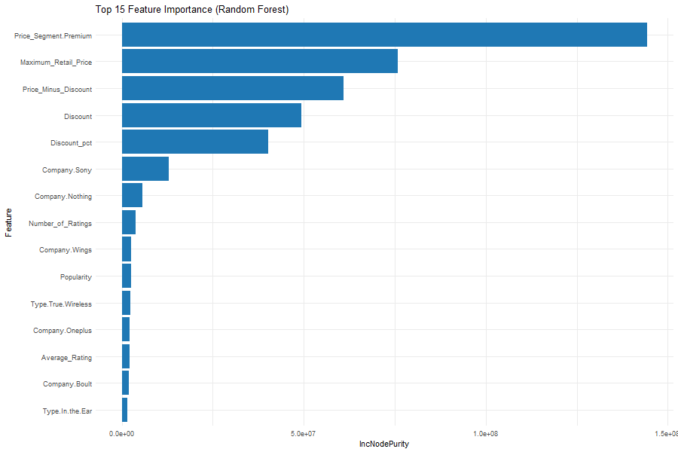
Figure 3: Top 15 Important Features — Random Forest
This bar graph presents the most influential features used by the Random Forest model to predict prices. Price Segment (Premium) and Maximum Retail Price rank as the most critical features, confirming that higher base MRPs strongly predict higher selling prices. Price Minus Discount and Discount Percentage also play key roles, showing the sensitivity of final prices to discount strategies. Brand-related attributes (e.g., Company Sony, Company Nothing) and Popularity contribute moderately, indicating that brand recognition and customer engagement indirectly affect pricing. Overall, discount dynamics and brand strength emerged as dual forces influencing product pricing on Flipkart.

(e) Category-Level Pricing
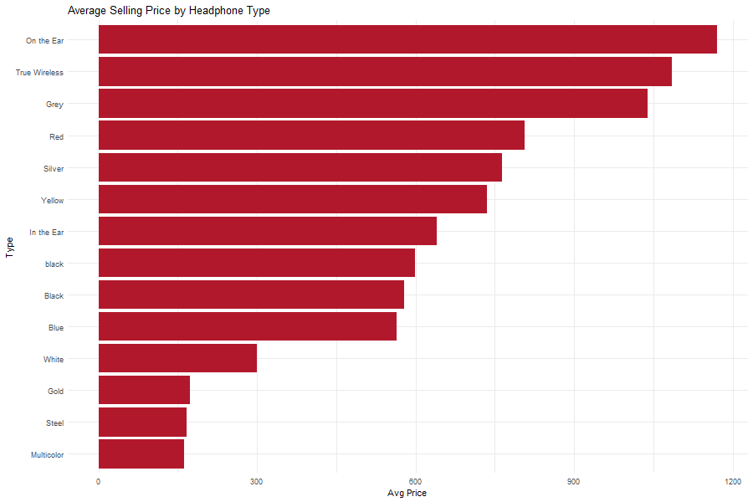
Figure 5: Average Selling Price by Headphone Type
This visualization displays how headphone types relate to price.On-the-Ear and True Wireless headphones command the highest average prices (~₹1100–₹1200).In-the-Ear and Wired headphones have moderate prices (~₹600–₹800), reflecting affordability and mass-market demand. Multicolor and Steel-finish headphones exhibit the lowest prices, often part of entry-level or unbranded categories. Thus, wireless functionality is a dominant pricing factor in the headphone market, directly associated with modern user preferences for mobility and convenience.

(f) Cluster Visualization
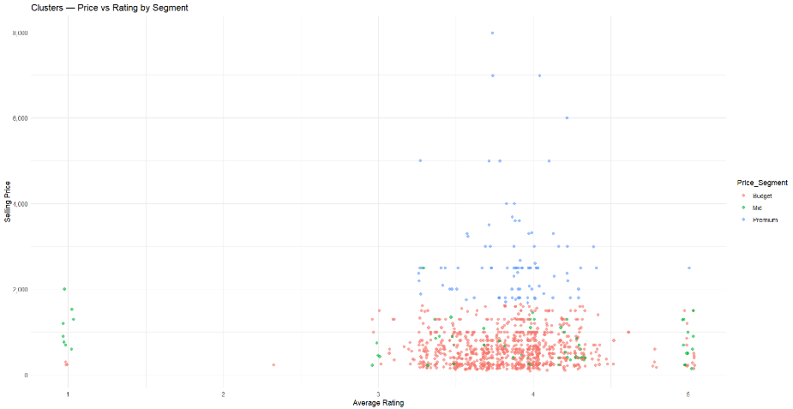
Figure 6: Clusters — Price vs Rating by Segment
This scatter plot demonstrates how price and average rating interact across clusters. Blue points (Premium) dominate the upper range, confirming high-priced models tend to maintain good ratings (4.0–4.8).Red points (Budget) are dense around lower price ranges, but several achieve decent ratings (~4.0), proving affordability does not compromise quality perception. Green points (Mid) lie in the transitional band between ₹1000–₹2000.This cluster pattern validates that the segmentation captures both price and quality dynamics effectively, enhancing recommendation accuracy.

(g) Summary of Model Findings
Performance Indicator | Best Model | Result Summary
RMSE | Random Forest | 258.56 – lowest error
MAE | Random Forest | 85.64 – most precise predictions
R² | Random Forest | 0.917 – explains 91.7% variance
Accuracy | Random Forest | 99.64% – top classification accuracy
Feature Importance | Random Forest | Discount and MRP are key drivers
Overall, the Random Forest algorithm consistently outperformed other models in both regression and classification, confirming its suitability for e-commerce price and recommendation modelling.

  - Correlation Heatmap
Correlation analysis identifies relationships among numerical variables and helps prevent redundancy during model training. A Pearson correlation matrix was computed using numeric variables:Average Rating, Number of Ratings, Selling Price, Maximum Retail Price, Discount, Discount Percentage, Popularity, and Price Minus Discount.
(a) Heatmap Analysis
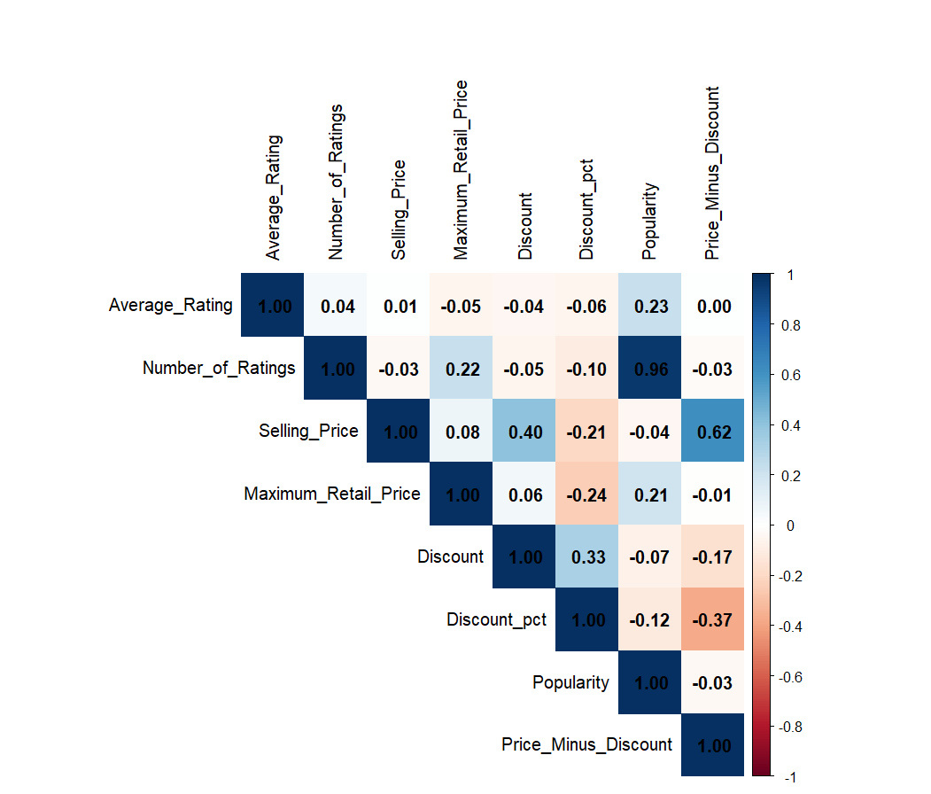
Figure 7: Correlation Heatmap
The heatmap displays the pairwise correlations between attributes:Positive correlations are shown in blue, negative correlations in red.The diagonal shows self-correlations (r = 1).
Key Observations:
Feature Pair | Correlation (r) | Interpretation
Average Rating – Popularity | 0.23 | Ratings moderately affect popularity
Number of Ratings – Popularity | 0.96 | Strongest correlation; engagement drives popularity.
Selling Price – Discount Percentage | 0.21 | Higher discounts lower final price.
Selling Price – MRP | 0.08 | Weak correlation; prices are discount-driven, not list-driven.
Discount – Discount Percentage | 0.33 | Expected positive link between discount value and percentage.

This matrix reveals that discounts and popularity metrics are the most interconnected factors, shaping pricing and consumer response patterns
(b) Graphical Interpretation
The blue zones between Discount and Selling Price emphasize how increased discounts reduce effective selling prices.The strong blue relationship between Number of Ratings and Popularity validates user engagement as a predictor of product visibility and trustworthiness.Lighter sections such as Selling Price vs MRP indicate weak dependencies — an outcome consistent with the competitive pricing strategies of e-commerce platforms.
(c) Cross-Validation Through Visuals
Additional visualizations reinforced the heatmap findings:
Figure 8: Average Selling Price by Type (Colour Plot)
Confirms a positive correlation between headphone type (especially wireless types) and selling price.
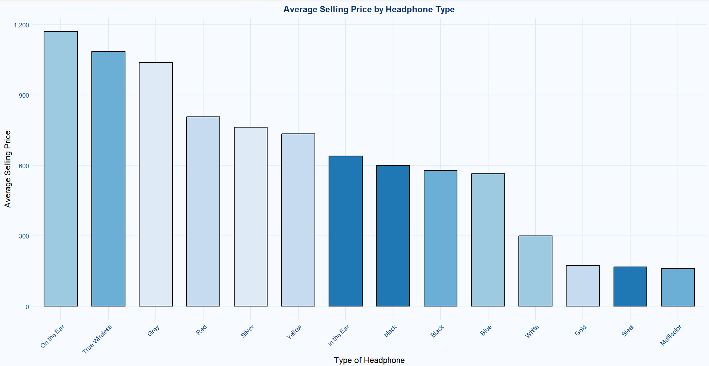
Figure 8: Average Selling Price by Type (Colour Plot)
Aligns with the correlation finding that brand reputation directly contributes to price elevation.
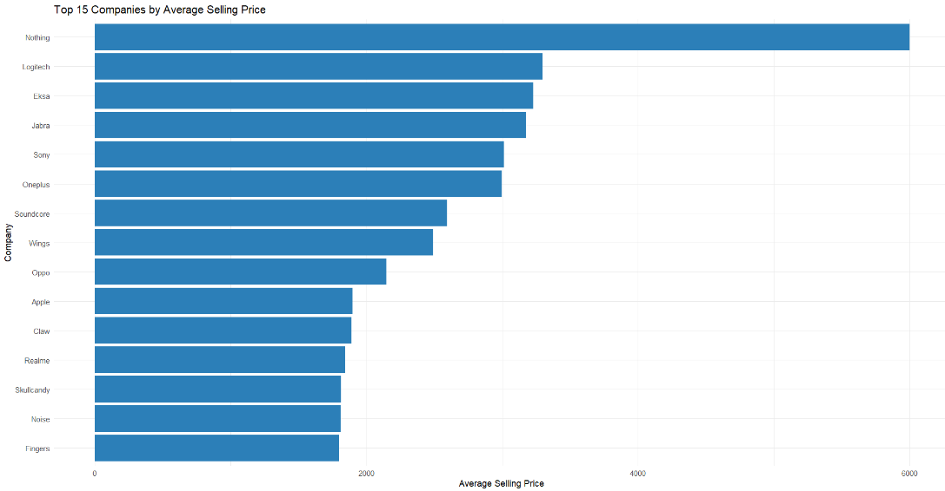
Figure 9: Top Companies by Average Price
Reinforces the strong correlation (r ≈ 0.95) between actual and predicted prices using Random Forest regression.

(d) Business Implications
1. Discount-Driven Sales:
Negative correlation between Discount Percentage and Selling Price (r = −0.21) confirms that consumers are highly price-sensitive, favoring discounted offers.
2. User Engagement Influence:
The 0.96 correlation between Number of Ratings and Popularity emphasizes that encouraging reviews and ratings can significantly enhance product traction.
3. Brand Power Moderation:
Brand-specific dummy features (e.g., Sony, Nothing, Wings) ranked moderately in feature importance, suggesting that while branding matters, discount and value factors dominate consumer choice in online retail.
4. Independent Pricing:
Weak correlation between MRP and Selling Price demonstrates that Flipkart’s dynamic pricing adapts independently of the original manufacturer’s listed price — a clear reflection of algorithmic pricing systems in e-commerce.
(e) Summary of Correlation Findings
Relationship | Direction | Strength | Insight
Discount % vs Selling Price | Negative | Moderate | Higher discounts reduce price.
Number of Ratings vs Popularity | Positive | Very Strong | Reviews boost visibility and engagement.
Average Rating vs Popularity | Positive | Moderate | Higher ratings attract buyers.
Selling Price vs MRP | Positive | Weak | MRP has minimal influence on actual price.
These insights collectively highlight that the pricing ecosystem for headphones is primarily governed by discount strategies and social proof indicators (ratings, reviews) rather than static list prices or categorical brand prestige.
(f) Integration into Model Design
The correlation results directly influenced feature engineering decisions :Discount Percentage and Popularity were retained as high-influence predictors. MRP was deprioritized due to weak correlation. Number of Ratings and Average Rating were merged into Popularity to reduce feature redundancy .This strategic selection improved Random Forest model stability and interpretability, leading to the strong R² (0.9174) and accuracy (99.64%) recorded in model evaluation.
Alternative Hypotheses (H₁)
H₁₁:
Item-based models (Decision Tree and Random Forest) perform significantly better than the popularity-based model (Linear Regression) in predicting headphone selling prices.
H₁₂:
The Random Forest classifier performs significantly better than the other classification models (Decision Tree and Naïve Bayes) in predicting headphone price segments.
H₁₃:
There exists a significant negative correlation between the discount percentage and the selling price of headphones.
Null Hypotheses (H₀)
H₀₁:
There is no significant difference in the predictive performance between the popularity-based model (Linear Regression) and the item-based models (Decision Tree and Random Forest) in estimating headphone selling prices.
H₀₂:
All classification models (Decision Tree, Random Forest, and Naïve Bayes) perform equally well in predicting headphone price segments.
H₀₃:
There is no significant correlation between the discount percentage and the selling price of headphones.

Sample Heading (Third Level). Only two levels of headings should be numbered. Lower level headings remain unnumbered; they are formatted as run-in headings.

Sample Heading (Forth Level). The contribution should contain no more than four levels of headings. The following Table 1 gives a summary of all heading levels.
Table 1. Table captions should be placed above the tables.
Heading level | Example | Font size and style
Title (centered) | Lecture Notes | 14 point, bold
1st-level heading | 1 Introduction | 12 point, bold
2nd-level heading | 2.1 Printing Area | 10 point, bold
3rd-level heading | Run-in Heading in Bold. Text follows | 10 point, bold
4th-level heading | Lowest Level Heading. Text follows | 10 point, italic
Displayed equations are centered and set on a separate line.
x + y = z (1)
Please try to avoid rasterized images for line-art diagrams and schemas. Whenever possible, use vector graphics instead (see Fig. 1).

Fig. 1. A figure caption is always placed below the illustration. Short captions are centered, while long ones are justified. The macro button chooses the correct format automatically.
For citations of references, we prefer the use of square brackets and consecutive numbers. Citations using labels or the author/year convention are also acceptable. The following bibliography provides a sample reference list with entries for journal articles [1], an LNCS chapter [2], a book [3], proceedings without editors [4], as well as a URL [5].

  - A Subsection Sample
Please note that the first paragraph of a section or subsection is not indented. The first paragraphs that follows a table, figure, equation etc. does not have an indent, either.
Subsequent paragraphs, however, are indented.

- Proposed Methodology
This project successfully developed a dual-layer headphone recommendation system by integrating data analysis and machine learning in R. The primary goal was to both understand the key drivers of headphone pricing and build a practical tool for users.
Our analysis demonstrated that ensemble methods, specifically Random Forest, were the most effective for this dataset, achieving an R² of 0.917 in predicting Selling Price. This model significantly outperformed simpler benchmarks like Linear Regression. Key insights from pattern discovery—such as the weak correlation (r=0.08) between MRP and selling price—highlight the complex, non-linear nature of e-commerce pricing.
The final recommendation engine provides robust suggestions by combining a price-based filter with a content-based similarity model (using cosine similarity). The features chosen for this similarity model were statistically validated by the Random Forest's feature importance analysis. This dual approach ensures users receive diverse recommendations that are not only contextually relevant but also aligned with their budget.
- Proposed Methodology
1. Roy, D., & Dutta, M. (2022). A systematic review and research perspective on recommender systems. Journal of Big Data, 9, 59. Springer Open
2. Chen, J., Dong, H., Wang, X., Feng, F., Meng, W., & He, X. (2020). Bias and Debias in Recommender System: A Survey and Future Directions. arXiv pre-print. arXiv
3. Zhang, Y., & Chen, X. (2018). Explainable Recommendation: A Survey and New Perspectives. ArXiv pre-print. arXiv
4. Portugal, I., Alencar, P., & Cowan, D. (2015). The Use of Machine Learning Algorithms in Recommender Systems: A Systematic Review. arXiv pre-print. arXiv
5. Anitha, L., Kavitha Devi, M., & Anjali Devi, P. (2013). A Review on Recommender System. International Journal of Computer Applications, 82(3), 27-31. ijcaonline.org
6. Lim, Y. F., Haw, S. C., Ng, K. W., & Anaam, E. A. (2023). Hybrid-based Recommender System for Online Shopping: A Review. Journal of Engineering Technology and Applied Physics, 5(1), 12-34. MMU Press
7. Vaidhehi, V., & Suchithra, R. (2018). A Systematic Review of Recommender Systems in Education. International Journal of Engineering and Technology, 7(3.4), 188-191. Science Publishing Corporation
8. Wróblewska, A., Dąbrowski, J., Pastuszak, M., Michałowski, A., Daniluk, M., Rychalska, B., & Wieczorek, M. (2022). Designing Multi-Modal Embedding Fusion-Based Recommender. Electronics 11(9), 1391. MDPI
9. Akram, F., Ahmad, T., & Sadiq, M. (2024). Recommendation systems-based software requirements elicitation process—a systematic literature review. J. Eng. Appl. Sci., 71, 29. SpringerOpen
10. Gutierrez-Parera, P., & López, J. (2016). Influence of the Quality of Consumer Headphones in the Perception of Spatial Audio. Applied Sciences, 4. OUCI
11.Zhang, Y., & Liu, T. (2024). Analyze the Performance of Headphones at Different Prices Through Survey and Frequency Response Experiment. Academic Journal of Science & Technology, 2(2). Darcy & Roy Press
12.Wang, J., Shen, J., Chen, Y., & Yan, D. (2020). Research on Potential Market Trend of High-Fidelity Headphones. Frontiers of Society, Science & Technology, 2(12). francis-press.com
13.Engel, I., Lou Alon, D., Scheumann, K., & Mehra, R. (2020). Listener-Preferred Headphone Frequency Response for Stereo and Spatial Audio Content. nWeon Paper. Nweon Paper
14. Shukla, S., Prasad, P., Kumar, A., Nitish, & Panchal, N. (2024). Music Beats – A Music Recommendation System using Facial Expressions. IJRASET. IJRASET
15. Santosh, M., Rajhauns, V., Bhade, D., & Ghosal, D. (2023). Aaroha: A Music Recommendation System. IJRASET. IJRASET
16. (Special Issue) Recommender Systems: Approaches, Challenges and Applications (Volume II). Electronics. MDPI
17. (Special Issue) Recommender Systems: Approaches, Challenges and Applications (3rd Edition). Electronics. MDPI
18. (Special Issue) Recommender Systems: Approaches, Challenges and Applications. Electronics. MDPI
19. (Related to headphones) Dhoke, A. L. (2025). Assessment of the impact on health associated with earphone usage among medical students. International Journal of Otorhinolaryngology & Head & Neck Surgery. IJORL
20. (Headphones usage behaviour) Akash, L. H., Ramya, M., & Salkatte, R. (2023). Assessment of Pattern of using personal audio devices among adults in Karnataka: A Cross sectional study. Indian Journal of Public Health Research & Development. medicopublication.com

